Claude Certification — Building with the Claude API
Section 9 — Anthropic Apps: Claude Code and Computer Use
Contents
- Lesson 1 — Anthropic Apps
- Lesson 2 — Claude Code Setup
- Lesson 3 — Claude Code in Action
- Lesson 4 — Enhancements with MCP Servers

Lesson 1 — Anthropic Apps

Core idea
This module explores two applications built by Anthropic — Claude Code and Computer Use — as real-world case studies of AI agents in action. Understanding how they work lays the foundation for building agents later in the course.

Our Plan
The module follows a step-by-step progression: start with Claude Code, an agentic coding assistant that runs in the terminal; then explore Computer Use, a set of tools that lets Claude interact with a desktop computer environment; and finally look at what makes both of these applications successful as agents.
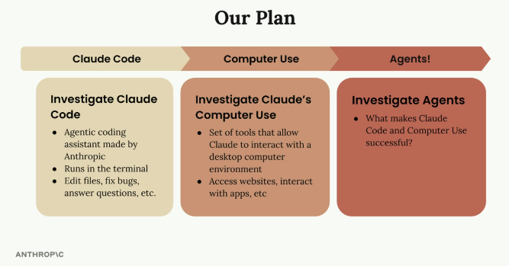
The module's progression: investigate Claude Code (agentic coding assistant, runs in the terminal, edits files/fixes bugs/answers questions) → investigate Computer Use (tools that let Claude interact with a desktop environment, access websites, interact with apps) → investigate Agents (what makes Claude Code and Computer Use successful).

Claude Code
Claude Code is a terminal-based coding assistant that helps with programming tasks — like having Claude available right in the command line, ready to edit files and fix bugs, answer coding questions, and help with development workflows. The module walks through the complete setup process and then uses Claude Code on a small sample project to show exactly how it operates in practice.

Computer Use
Computer Use takes Claude's capabilities further: it's a collection of tools that let Claude interact with a full desktop computer environment, so Claude can access websites and browse the internet, interact with desktop applications, and perform tasks that require visual interface navigation. This dramatically expands what's possible compared to text-only interactions.

Why These Matter for Agents
Both Claude Code and Computer Use serve as case studies for understanding agents, demonstrating key principles that make agents effective:
- Tool integration and usage
- Multi-step task execution
- Environmental interaction
- Autonomous problem-solving
Examining these real-world implementations gives insight into what makes Claude Code and Computer Use successful, which informs later agent development work in the course.

Practice Questions — Lesson 1
Choose the single best answer for each question (A–E).
1. Why are Claude Code and Computer Use used as the starting point for this module on agents?
A) Because they are the only tools Anthropic has ever released
B) Because they are real-world case studies of AI agents in action, useful as a foundation for building agents later
C) Because they require no setup at all
D) Because they replace the need to learn about tool use
E) Because they only work with Claude Haiku
2. What is Claude Code, according to the lesson?
A) A browser extension for Claude.ai
B) A terminal-based coding assistant that can edit files, fix bugs, answer coding questions, and help with development workflows
C) A cloud IDE hosted by Anthropic
D) A tool exclusively for writing documentation
E) A GUI-only application with no command-line component
3. What does Computer Use allow Claude to do that goes beyond text-only interactions?
A) Only generate longer text responses
B) Interact with a full desktop computer environment — access websites, interact with apps, navigate visual interfaces
C) Train new versions of itself
D) Directly modify its own model weights
E) Bypass the need for an API key
4. Which of the following is NOT listed as a key principle that Claude Code and Computer Use demonstrate for effective agents?
A) Tool integration and usage
B) Multi-step task execution
C) Environmental interaction
D) Autonomous problem-solving
E) Guaranteed zero-cost API usage
5. According to the module's plan, what is the third and final topic to be investigated after Claude Code and Computer Use?
A) Prompt caching
B) Agents — what makes Claude Code and Computer Use successful
C) RAG pipelines
D) The Files API
E) Extended thinking

Lesson 2 — Claude Code Setup

Core idea
Claude Code is a terminal-based coding assistant that runs directly in the command line — Claude available right in the terminal, ready to help with any coding task.

What Claude Code Can Do
Claude Code comes with a comprehensive set of tools for the development workflow:
- File operations — search, read, and edit files in the project
- Terminal access — run commands directly from the conversation
- Web access — search documentation, fetch code examples, and more
- MCP Server support — add additional tools by connecting MCP servers
The MCP integration is particularly powerful: it means Claude Code's capabilities can be extended by adding specialized tools for databases, APIs, or any other services being worked with. Claude Code works across MacOS, Windows WSL, and Linux, so it can be used regardless of the development environment.
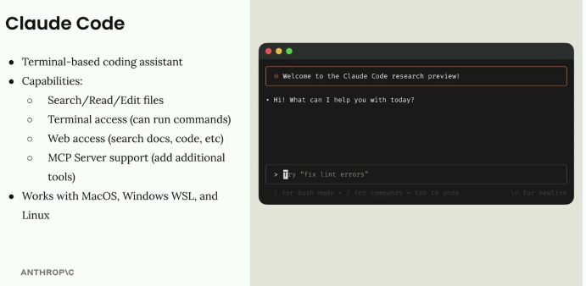
Claude Code: terminal-based coding assistant with file search/read/edit, terminal access, web access, and MCP Server support, running on MacOS, Windows WSL, and Linux. The terminal panel shows the Claude Code research preview welcome screen with a prompt ready for a request like "fix lint errors".

Installation
Getting Claude Code set up takes three steps:
1. Install Node.js from nodejs.org/en/download (check if it's already installed by running npm help in the terminal).
2. Install Claude Code with the command: npm install -g @anthropic-ai/claude-code.
3. Start and log in by running claude in the terminal.
Running the claude command for the first time prompts a login to the Anthropic account. The full setup guide is available at docs.anthropic.com for more detailed instructions. Once set up, Claude is available directly in the terminal, ready to help with any coding project or task.

Practice Questions — Lesson 2
Choose the single best answer for each question (A–E).
1. What is Claude Code, according to the lesson?
A) A browser extension that only works on Chrome
B) A terminal-based coding assistant available right in the command line
C) A cloud-hosted IDE with no local installation
D) A tool exclusively for writing tests
E) A GUI application with no command-line component
2. Which capability makes it possible to extend Claude Code with tools for databases, APIs, or other services?
A) Terminal access
B) MCP Server support
C) File operations
D) Web access
E) None — Claude Code's toolset is fixed and cannot be extended
3. Which operating systems does Claude Code support, according to the lesson?
A) Only MacOS
B) MacOS, Windows WSL, and Linux
C) Only Linux and Android
D) Windows native only, no WSL
E) Any OS with a web browser, no terminal required
4. What is the correct order of installation steps for Claude Code?
A) Run claude, install Node.js, then install the npm package
B) Install Node.js, install Claude Code via npm, then run claude to start and log in
C) Log in to Anthropic first, then install Node.js, then install Claude Code
D) Install Claude Code via npm only — Node.js is not required
E) Download a standalone installer from docs.anthropic.com, no npm needed
5. What happens the first time the claude command is run in the terminal?
A) It immediately deletes all files in the current directory
B) It prompts a login to the Anthropic account
C) It silently fails without further messages
D) It automatically installs Node.js
E) It opens a web browser with no terminal interaction needed

Lesson 3 — Claude Code in Action

Core idea
Claude Code isn't just for writing code — it's designed to work alongside the developer through every phase of a software project, like another engineer who can handle everything from initial setup to deployment and support.
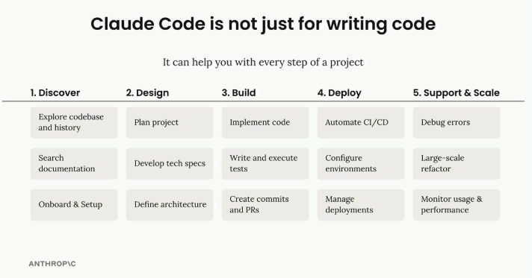
Claude Code can help across all 5 steps of a project: Discover (explore codebase/history, search documentation, onboard & setup), Design (plan project, develop tech specs, define architecture), Build (implement code, write/execute tests, create commits and PRs), Deploy (automate CI/CD, configure environments, manage deployments), and Support & Scale (debug errors, large-scale refactor, monitor usage & performance).

The /init Command
The first thing to run when starting with Claude Code on a project is /init, which tells Claude to scan the entire codebase and understand its structure, dependencies, coding style, and architecture. Claude summarizes everything it learns in a special file called CLAUDE.md, which is automatically included as context in all future conversations, so Claude remembers important details about the project.
There can be multiple CLAUDE.md files for different scopes:
- Project — shared between all engineers working on the project
- Local — personal notes that aren't checked into git
- User — used across all projects
Running /init allows adding special directions for areas Claude should focus on; the generated file includes build commands, coding guidelines, and project-specific patterns Claude should follow. Notes can also be added quickly to CLAUDE.md with the # command — for example, typing "# Always use descriptive variable names" prompts adding this guideline to the project, local, or user memory.

Common Workflows
Claude works best when approached as an effort multiplier: the more context and structure provided, the better the results.
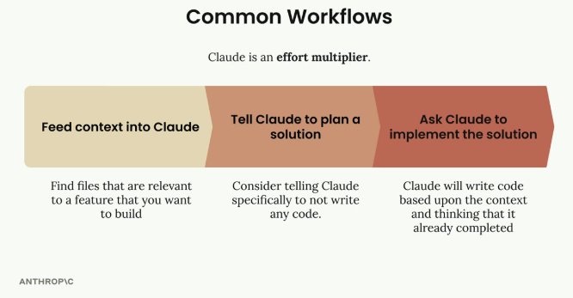
The most effective workflow: (1) Feed context into Claude — find files relevant to the feature to build; (2) Tell Claude to plan a solution — specifically not to write any code yet; (3) Ask Claude to implement the solution — Claude writes code based on the context and thinking already completed.
Step 1 — Feed Context into Claude: before asking Claude to build something, identify files in the codebase relevant to the feature, and ask Claude to read and analyze them first — this gives Claude examples of existing coding patterns and functionality to build upon.
Step 2 — Tell Claude to Plan a Solution: instead of jumping straight to implementation, ask Claude to think through the problem and create a plan, specifically not writing any code yet — just the approach and steps needed.
Step 3 — Ask Claude to Implement the Solution: once there's a solid plan, ask Claude to implement it; Claude writes code based on the context and planning work already done together.

Test-Driven Development Workflow
For even better results, a test-driven approach can be used:
1. Feed context into Claude — same as before, show Claude relevant files.
2. Ask Claude to think of test cases — have Claude brainstorm what tests would validate the new feature.
3. Ask Claude to implement those tests — select the most relevant tests and have Claude write them.
4. Ask Claude to write code that passes the tests — Claude iterates on the implementation until all tests pass.
This approach often produces more robust code because Claude has clear success criteria to work toward. Before starting this workflow, remember to run /clear to clear conversation history and free up context.

Practical Example
Adding a document conversion tool to an existing project, following the three-step workflow:
// First, ask Claude to read relevant files
> Read the math.py and document.py files

// Then ask for planning (not implementation)
> Plan to implement document_path_to_markdown tool:
1. Create a function that:
- Takes a file path parameter
- Validates the file exists
- Determines file type from extension
- Reads binary data from file
- Leverages existing binary_document_to_markdown function
- Returns markdown string
2. Add appropriate documentation
3. Register the tool with MCP server
4. Add tests

// Finally, ask for implementation
> Implement the plan
Claude then creates the function, updates the necessary files, writes tests, and even runs the test suite to verify everything works correctly.

Additional Commands
- /clear — clears conversation history and resets context
- /init — scans the codebase and creates CLAUDE.md documentation
- # — adds notes to the CLAUDE.md file
Claude can also handle routine development tasks like staging and committing changes to git, running tests, and managing dependencies — instead of switching between editor and terminal, these tasks can be handled by Claude while the developer focuses on the bigger picture. The key to success with Claude Code is treating it as a collaborative partner, not just a code generator: the more context and structure provided, the more effectively Claude can help build and maintain projects.

Practice Questions — Lesson 3
Choose the single best answer for each question (A–E).
1. What does the /init command do?
A) It installs Node.js automatically
B) It scans the codebase and generates a CLAUDE.md file summarizing structure, dependencies, coding style, and architecture
C) It deletes all CLAUDE.md files
D) It connects Claude Code to an MCP server
E) It clears the conversation history
2. What is the difference between Project, Local, and User CLAUDE.md scopes?
A) They are identical and interchangeable
B) Project is shared between all engineers, Local is personal and not checked into git, User applies across all projects
C) Only Project scope is ever used in practice
D) Local scope is shared publicly on GitHub by default
E) User scope only applies to a single file in the project
3. In the recommended common workflow, what should you explicitly tell Claude NOT to do during the planning step?
A) Read any files
B) Write any code yet
C) Ask clarifying questions
D) Create a plan
E) Use the # command
4. What is the purpose of running /clear before starting the test-driven development workflow?
A) To permanently delete the CLAUDE.md file
B) To clear conversation history and free up context
C) To uninstall Claude Code
D) To reset the git repository
E) To switch from MacOS to Linux
5. According to the lesson, what mindset leads to the most effective use of Claude Code?
A) Treating it purely as a code generator with minimal input
B) Treating it as a collaborative partner and effort multiplier — providing more context and structure for better results
C) Avoiding the use of CLAUDE.md files entirely
D) Only using it for deployment tasks, never for planning
E) Running /init only once per year

Lesson 4 — Enhancements with MCP Servers

Core idea
Claude Code has an MCP client built right into it, so connecting MCP servers dramatically expands what Claude can do — opening up powerful possibilities for customizing the development workflow.

How MCP Extends Claude
The Model Context Protocol lets Claude Code connect to external services and tools through MCP servers. Instead of being limited to Claude's built-in capabilities, custom functionality can be added by connecting servers that provide specific tools, resources, or integrations. Each MCP server can expose different types of functionality to Claude through three main components: Tools (for taking actions), Prompts (for templates), and Resources (for accessing data).
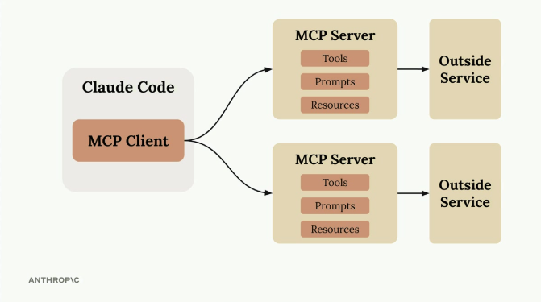
Claude Code's built-in MCP Client connects to multiple MCP Servers, each bundling Tools, Prompts, and Resources, and each acting as an interface to an outside service.

Setting Up an MCP Server
Adding an MCP server to Claude Code is done from the command line, registering the server with:
claude mcp add [server-name] [command-to-start-server]
For example, for a document processing server that starts with uv run main.py:
claude mcp add documents uv run main.py
Once registered, Claude Code automatically connects to the server when it starts up.

Example: Document Processing
A practical example is a tool that lets Claude read PDF and Word documents: building an MCP server with a "document_path_to_markdown" tool makes it possible to ask Claude to convert document contents to markdown format. Asking Claude to "Convert the tests/fixtures/mcp_docs.docx file to markdown" automatically uses the custom tool to read the document and return the converted content.
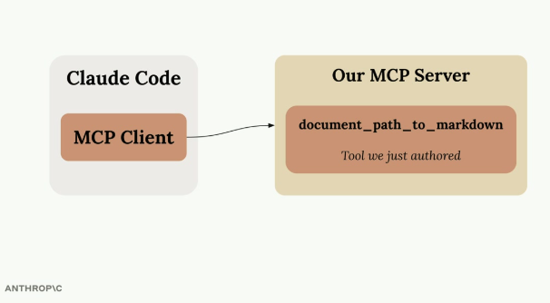
Claude Code's MCP Client calls Our MCP Server, which exposes the document_path_to_markdown tool — the tool just authored for converting documents to markdown.

Popular MCP Integrations
The MCP ecosystem includes servers for many common development tools and services.
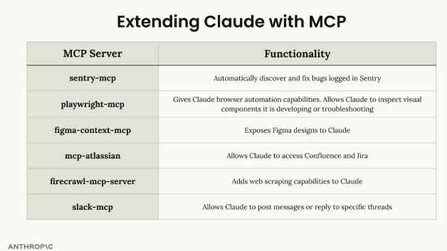
Examples of MCP servers and what they add: sentry-mcp (auto-discover and fix bugs logged in Sentry), playwright-mcp (browser automation, inspect visual components), figma-context-mcp (exposes Figma designs to Claude), mcp-atlassian (access to Confluence and Jira), firecrawl-mcp-server (web scraping capabilities), slack-mcp (post messages or reply to specific threads).

Building Your Development Workflow
The real power comes from combining multiple MCP servers that match a specific development process — for example:
- A Sentry server to fetch production error details
- A Jira server to read ticket requirements
- A Slack server to notify the team when work is complete
- Custom servers for internal tools and APIs
This creates a development environment where Claude can seamlessly work with all the tools and services already in use, making it a much more powerful coding assistant tailored to a specific workflow.

Practice Questions — Lesson 4
Choose the single best answer for each question (A–E).
1. What does Claude Code have built in that lets it connect to MCP servers?
A) A web browser
B) An MCP client
C) A Docker runtime
D) A dedicated GPU scheduler
E) A built-in Slack integration only
2. What are the three main components an MCP server can expose to Claude?
A) Tools, Prompts, and Resources
B) Users, Roles, and Permissions
C) Logs, Metrics, and Alerts
D) Files, Folders, and Repositories
E) Sessions, Tokens, and Keys
3. What is the command used to register a new MCP server with Claude Code?
A) npm install -g @anthropic-ai/claude-code
B) claude mcp add [server-name] [command-to-start-server]
C) claude mcp connect --server
D) mcp init [server-name]
E) claude --add-mcp [server-name]
4. In the document processing example, what does the document_path_to_markdown tool do?
A) It deletes the original document after conversion
B) It lets Claude read PDF and Word documents and convert their contents to markdown format
C) It only works with .txt files
D) It uploads the document to a cloud storage bucket
E) It translates the document into another language
5. According to the lesson, what creates the real power of an MCP-enhanced development workflow?
A) Using only the Sentry MCP server and nothing else
B) Combining multiple MCP servers that match the specific development process, like Sentry, Jira, Slack, and custom internal servers
C) Avoiding any MCP servers and relying only on Claude's built-in capabilities
D) Registering as many servers as possible regardless of relevance
E) Replacing Claude Code with a different tool entirely

